# COMP1562, Lab #8 File systems

|  |  |  |  |
| --- | --- | --- | --- |
| Lecturer | **Mariusz Pelc** | Phone | **020 83318588** |
| Office | **QM366** | e-mail address | [**m.pelc@gre.ac.uk**](mailto:m.pelc@gre.ac.uk) |
| Office hours | **Mon 4-5pm, Wed 9-10pm** |  |  |

**(by M. Pelc and K. McManus)**

**Description:**

**This exercise is mainly focused on files allocation algorithms and on understanding how specified file systems-related tools and mechanism work.**

**Learning Outcomes:**

**Students will be able to understand the way some selected file allocation algorithms work.**

**REPORT**

**Describe the following .**

1. You are supposed to write a brief, coherent report (in total of 4 pages long) comparing, contrasting or describing the following disk monitoring and disk maintenance tools for Linux and Windows systems.
2. **fsck** (Linux) vs **scandisk** (Windows).

1. **mkfs** (Linux) vs **format** (Windows).

1. **Logical Volume Manager** (Linux) vs **Logical Disk Manager** (Windows).

1. **S.M.A.R.T.** utility.

**TASKS**

1. **Using the template provided on the scriptcheck system show the result of allocating of 3 files using contiguous file allocation algorithm. Assume the following:**

* Fixed storage (disk) space of 250B.
* Block size 1B.
* There are already 3 pre-allocated files on the disk: first of the files contains ‘%’, second contains ‘^’ and third contains ‘&’.
* Unused blocks are marked as ‘0’.

Pre-allocate 3 files are:

File X: size 15B, content: ‘%’, start block: 10

File Y: size 10B, content: ‘^’, start block: 30

File Z: size 33B, content: ‘&’, start block: 66

Number of files to allocate: 3

File A size: 14B, content: ‘a’,

File B size: 30B, content: ‘b’,

File C size: 12B, content: ‘c’.

DISK SPACE:

0: 00 00 00 00 00 %% %% %% %% %% %% %% %

25: 00 00 0^ ^^ ^^ ^^ ^^ ^0 00 00 00 00 0

50: 00 00 00 00 00 00 00 00 && && && && &

75: && && && && && && && && && && && && 0

100: 00 00 00 00 00 00 00 00 00 00 00 00 0

125: 00 00 00 00 00 00 00 00 00 00 00 00 0

150: 00 00 00 00 00 00 00 00 00 00 00 00 0

175: 00 00 00 00 00 00 00 00 00 00 00 00 0

200: 00 00 00 00 00 00 00 00 00 00 00 00 0

225: 00 00 00 00 00 00 00 00 00 00 00 00 0

0:0000000000%%%%%%%%%%%%%%%

25:00000^^^^^^^^^^aaaaaaaaaa

50:aaaacccccccccccc&&&&&&&&&

75:&&&&&&&&&&&&&&&&&&&&&&&&b

100:bbbbbbbbbbbbbbbbbbbbbbbbb

125:bbbb000000000000000000000

150:0000000000000000000000000

175:0000000000000000000000000

200:0000000000000000000000000

225:0000000000000000000000000

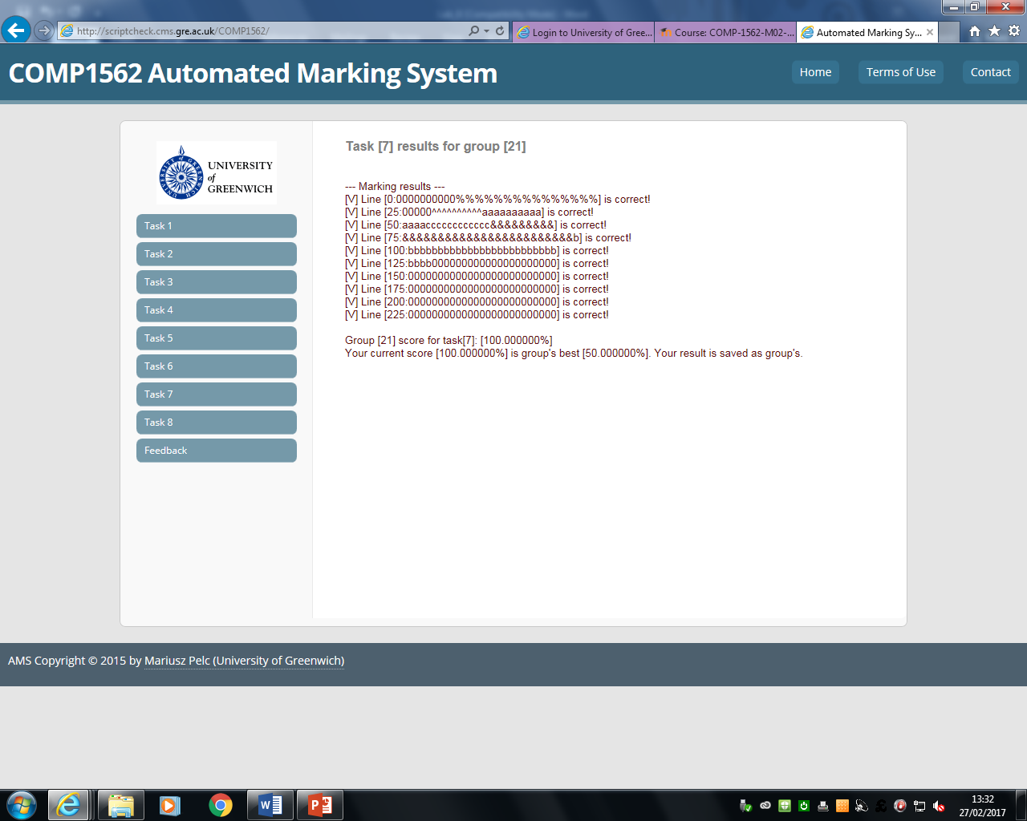

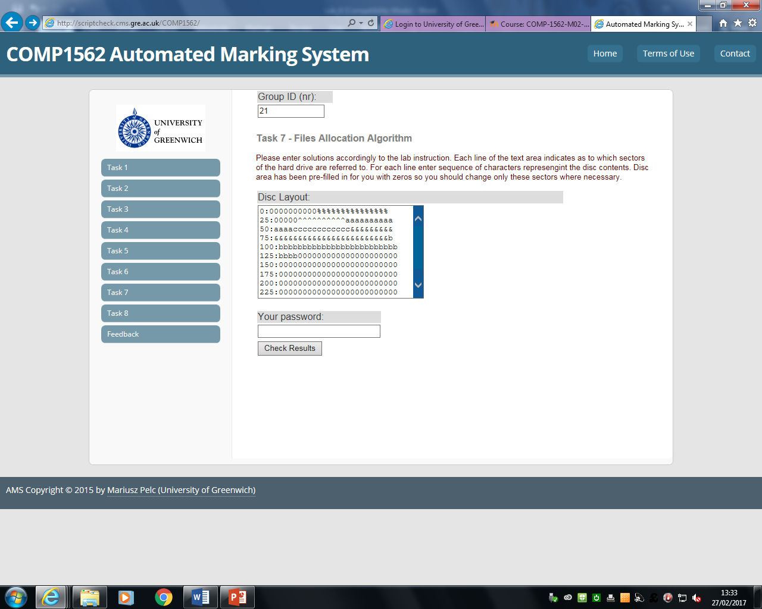

|  |
| --- |
| **While entering results please make sure the number of characters in each line does not change in comparison to the initial number one and that you modify ONLY the disk layout (replace ‘0’ with the appropriate character, depending on where the A, B & C files should be allocated.** |

**Techniques/resources:**

**Solution of all the above tasks does not require anything except scriptcheck system to enter solutions and calculator to for calculations.**

**Marking:**

**The solutions will be marked in the range 0-100%.**

**Deadline:**

**The solutions should be delivered within one week from the lab date.**

# COMP1562, Lab #8 Marking sheet

Peer mark for group: [provide group ID here]

|  |  |  |  |  |
| --- | --- | --- | --- | --- |
| **REPORT** | **Status** | **Description** | | |
| ***1a*** |  | ***15 marks for describing each tool / mechanism if it is correct and if it contains (wherever it is possible) some implementation / usage examples; each description should be about 1 page long. Lack of implementation / usage examples should be reflected in the marking sheet by deducting 5 marks.*** | | |
| ***1b*** |  |  | | |
| ***1c*** |  |  | | |
| ***1d*** |  |  | | |
| ***Score from AMS*** |  | | | |
| ***Name*** | |  | ***ID*** |  |
| ***Name*** | |  | ***ID*** |  |
| ***Name*** | |  | ***ID*** |  |
| ***Name*** | |  | ***ID*** |  |
| ***Name*** | |  | ***ID*** |  |
| **Exercise part mark** | |  | | |
| **Date** | |  | | |
| **Signature** | |  | | |

The marking sheet should be filled in by designated member of the marking group (make sure that each group member will mark at least one upload during the term time) then dated and then signed. After that it should be scanned / photographed, then copy-pasted / inserted into WORD document saved into a file named according to the convention:

**GID_TID_MarkingSheet.docx**

where **GID** is the marked group ID and the **TID** is the task that you marked.

The document should be uploaded to the scriptcheck.cms.gre.ac.uk server using FTP client. The username to FTP service on the scriptcheck.cms.gre.ac.uk server is ‘peerm’ and the password is ‘!1peerm’. All groups will be uploading into the same directory so please make sure you apply the file naming convention. Also, after uploading the file to the server you will not be able to delete the file (the server allows uploading, but not deleting files).

**The marked group (when requested) should provide the marking person with the uploaded work that is subject of marking (electronic version or printout) and notify the marking person what was the group score for the tasks awarted by the AMS.**

**Please mind that you should NOT provide your solutions to the marking group before deadline for uploading this lab results.**